This documentation tells how to set DJI m100 for onboard flight.

Largely, three part exists.

1. DJI m100 setting

1-1) Make DJI account and App

1-2) Install DJI assistant2 and set parameter

1-3) Set USB-TTL convertor for serial communication

2. Onboard computer setting

2-1) Install FFMPEG

2-2) Install ROS

2-3) Install opencv

2-4) Install dji-osdk

2-5) dji-osdk parameter setting

2-6) Install dji-osdk-ros

2-7) dji-osdk-ros parameter setting

3. Connection Onboard computer with m100 and Test

3-1) drone activation (through DJI GO app)

3-2) execute dji-osdk without ROS

3-3) execute dji-osdk-ros with ROS

4. Possible error and solution

1. DJI m100 setting

1-1) Make DJI account and App

Make DJI account from below link.

<https://developer.dji.com/>

Then, Create App at Developer Center of DJI developer homepage.

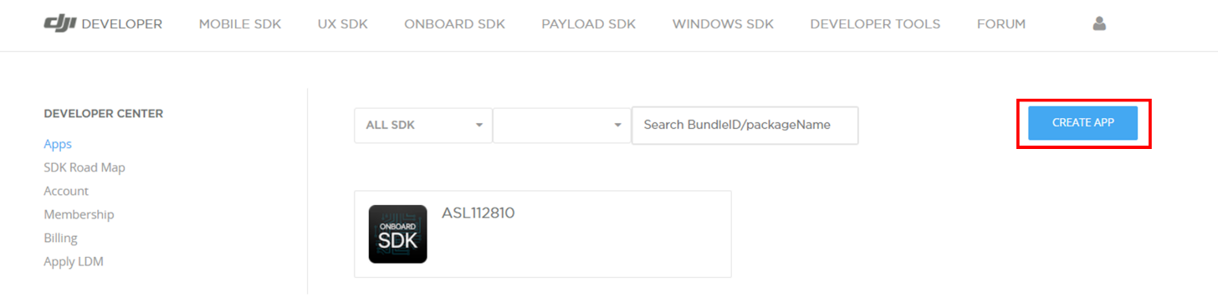

Then, You can get App ID and App Key. These Information are used later.

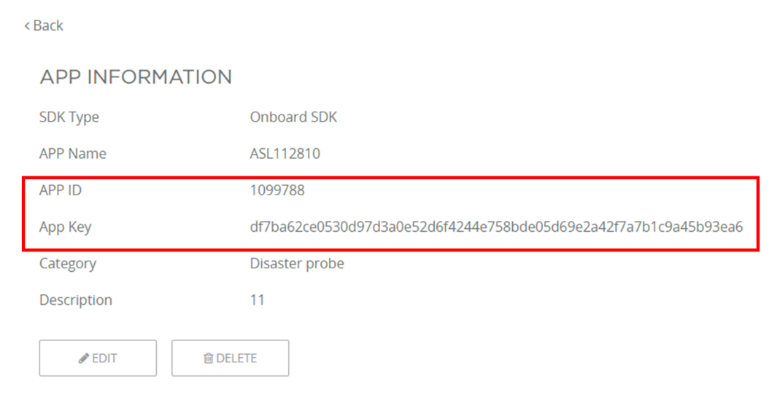

1-2) Install DJI assistant2 and set parameter

Install DJI assistant2 for m100 from below link.

https://www.dji.com/kr/downloads/softwares/assistant-dji-2

execute DJI assistnat2 and log in. then, Click settings and Turn on below settings.

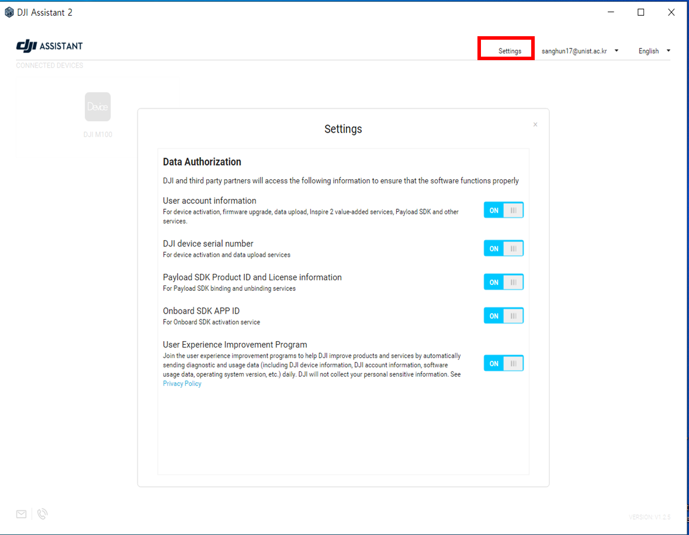

In the SDK tab, Set some parameters. The parameters in red box must be same as below.

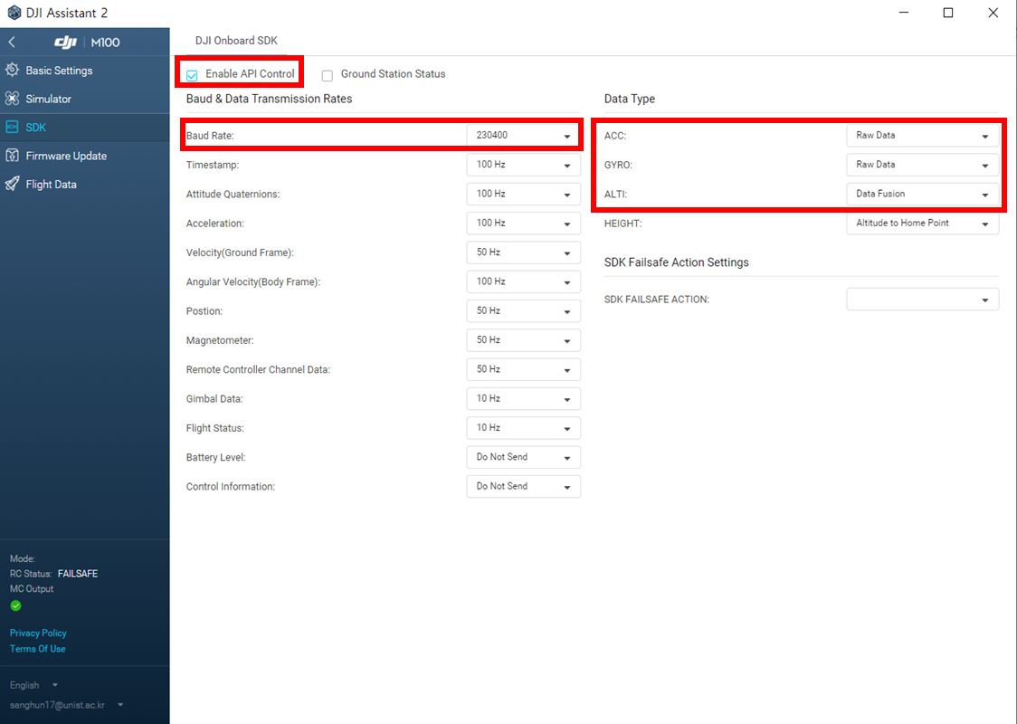

1-3) Set USB-TTL convertor for serial communication

According to manual of DJI m100, make USB-TTL convertor. Connect to UART_CAN2 of m100.

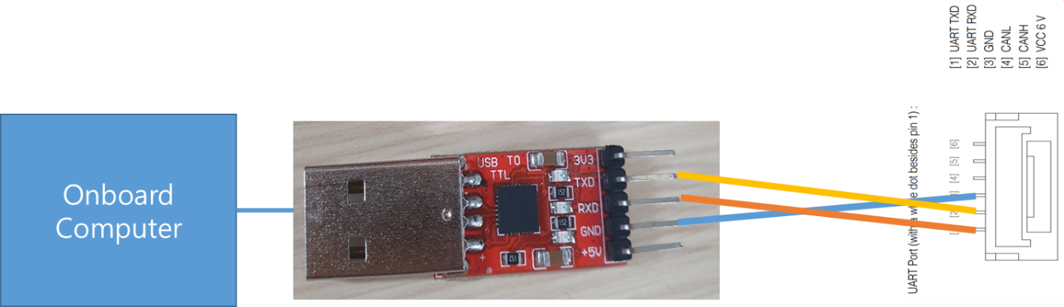

2. Onboard computer setting

1-1) Install FFMPEG

cd ~/

wget https://www.ffmpeg.org/releases/ffmpeg-2.8.5.tar.bz2

tar -xvf ffmpeg-2.8.5.tar.bz2

cd ffmpeg-2.8.5

./configure --disable-yasm

make && make install

2-2) Install ROS

ROS version should be matched with your ubuntu version. for ubuntu 16, ROS kinetic

<http://wiki.ros.org/kinetic/Installation/Ubuntu>

2-3) Install opencv (at least, 3.4.0 version needed.)

<https://webnautes.tistory.com/1186>

2-4) dji-osdk isntall (3.9 version)

cd ~/

git clone https://github.com/dji-sdk/Onboard-SDK.git

cd Onboard-SDK

git checkout 295915e6da116aa2871760d3478bba7ebab2f5d9

mkdir build

cd build

cmake ..

sudo make install

2-5) dji-osdk parameter setting

change Userconfig.txt as below.

vim ~/Onboard-SDK/sample/platform/linux/common/UserConfig.txt

//////////////////

app_id : "your app_id"

app_key : "your app_key"

device : /dev/tty*** (in my case, /dev/ttyUSB0)

baudrate : 230400

//////////////////

copy UserConfig.txt file to ~/Onboard-SDK/build/bin

cp ~/Onboard-SDK/sample/platform/linux/common/UserConfig.txt ~/Onboard-SDK/build/bin/

2-6) dji-osdk-ros install (3.8 version)

cd catkin_ws/src

(if you don't have 'catkin_ws' amd 'src' folder, make it by using 'mkdir' command.

and do " catkin_init_workspace" command in the "catkin_ws/src" path. )

git clone https://github.com/dji-sdk/Onboard-SDK-ROS.git

cd Onboard-SDK-ROS

git checkout a476b746ed3414e86b41a5ed4d04cb32ddf274d0

cd ~/catkin_ws

catkin_make

2-7) dji-osdk-ros parameter setting

change sdk.launch. below example is my case.

Set appropriate parameter. 'app_id', 'app_key', 'acm_name', 'serial_name' and, 'baud_rate' should be changed.

especially, Set baud_rate identically with DJI Assistabt value. for m100, 230400.

rosed dji_sdk sdk.launch

////////////////////////

<launch>

<node pkg="dji_sdk" type="dji_sdk_node" name="dji_sdk" output="screen">

<!-- node parameters -->

<param name="acm_name" type="string" value="/dev/ttyUSB0"/>

<param name="serial_name" type="string" value="/dev/ttyUSB0"/>

<param name="baud_rate" type="int" value="230400"/>

<param name="app_id" type="int" value="XXXXXXXXX (for security, I deleted)"/>

<param name="app_version" type="int" value="1"/>

<param name="align_time" type="bool" value="false"/>

<param name="enc_key" type="string" value="XXXXXXXXX (for security, I deleted)"/>

<param name="use_broadcast" type="bool" value="false"/>

</node>

</launch>

////////////////////////

run the sample.

roslaunch dji_sdk sdk.launch

if it success, you can get below.

//////////////////////////////////////////////

... logging to /home/ubuntu/.ros/log/1c5ccb80-75c9-11eb-90df-a0a4c57be28d/roslaunch-ubuntu-GB-BKi7-H-A-7500-3563.log

Checking log directory for disk usage. This may take awhile.

Press Ctrl-C to interrupt

Done checking log file disk usage. Usage is <1GB.

started roslaunch server http://192.168.0.122:44747/

SUMMARY

========

PARAMETERS

* /dji_sdk/acm_name: /dev/ttyUSB0

* /dji_sdk/align_time: False

* /dji_sdk/app_id: 1099788

* /dji_sdk/app_version: 1

* /dji_sdk/baud_rate: 230400

* /dji_sdk/enc_key: df7ba62ce0530d97d...

* /dji_sdk/serial_name: /dev/ttyUSB0

* /dji_sdk/use_broadcast: False

* /rosdistro: kinetic

* /rosversion: 1.12.17

NODES

/

dji_sdk (dji_sdk/dji_sdk_node)

auto-starting new master

process[master]: started with pid [3573]

ROS_MASTER_URI=http://192.168.0.122:11311

setting /run_id to 1c5ccb80-75c9-11eb-90df-a0a4c57be28d

process[rosout-1]: started with pid [3586]

started core service [/rosout]

process[dji_sdk-2]: started with pid [3597]

STATUS/1 @ init, L55: Attempting to open device /dev/ttyUSB0 with baudrate 230400...

STATUS/1 @ init, L65: ...Serial started successfully.

STATUS/1 @ parseDroneVersionInfo, L727: Device Serial No. = XXXXXXXXX (for security, I deleted)

STATUS/1 @ parseDroneVersionInfo, L729: Hardware = M100

STATUS/1 @ parseDroneVersionInfo, L730: Firmware = 3.1.10.0

STATUS/1 @ parseDroneVersionInfo, L733: Version CRC = 0xA6453AAC

STATUS/1 @ initSubscriber, L778: Telemetry subscription mechanism is not supported on this platform!

STATUS/1 @ initMFIO, L981: MFIO is not supported on this platform!

STATUS/1 @ initHardSync, L1077: Hardware Sync is not supported on this platform!

STATUS/1 @ activate, L1313: version 0x3010A00

STATUS/1 @ activate, L1326: Activation successful

[ INFO] [1614079220.802071861]: drone activated

[ INFO] [1614079220.863543206]: Use legacy data broadcast to get telemetry data!

////////////////////////////////////

3. Connection Onboard computer with m100 and Test

3-1) drone activation (through DJI GO app)

See “New device error: part of 4. Possible error and soludtion

3-2) execute dji-osdk without ROS

move bleow directory

cd ~/Onboard-SDK/build/bin/

s

run desired sample.

./desired_smaple_name UserConfig.txt

for example,

./djiosdk-telemetry-sample UserConfig.txt

3-3) execute dji-osdk-ros with ROS

roslaunch dji_sdk sdk.launch

Open new terminal, and

rostopic echo /dji_sdk/imu

Then, you can see imu data.

4. possible error and solution

1)

CMake Warning at /opt/ros/kinetic/share/catkin/cmake/catkinConfig.cmake:76 (find_package):

Could not find a package configuration file provided by "image_transport"

with any of the following names:

sol)

sudo apt install ros-kinetic-image-transport ros-kinetic-image-transport-plugins

2) fatal error: tf/tf.h: No such file or directory

sol)

sudo apt install ros-kinetic-tf

3) New device error

sol) we should connect m100 to lightbridge2. bring lightbridge2 and turn on it. it will sound beeping. then, turn on the m100. beeping sound will be stop.

connect your phone and lightbridge2. and run dji_flightcontrol_sample. pop up message will appear on your phone. you can active your drone throught this message.

4) drone activation error/vehicle initialization failed when roslaunch dji_sdk sdk.launch

it occured due to "ADVENSED_SENSING=enadbled" in dji_sdk_node.cpp

just replace dji_sdk_node.cpp at the ~/catkin_ws/src/Onboard-SDK-ROS/dji_sdk/src/modules with modified dji_sdk_node.cpp. it is uploaded in this repository.